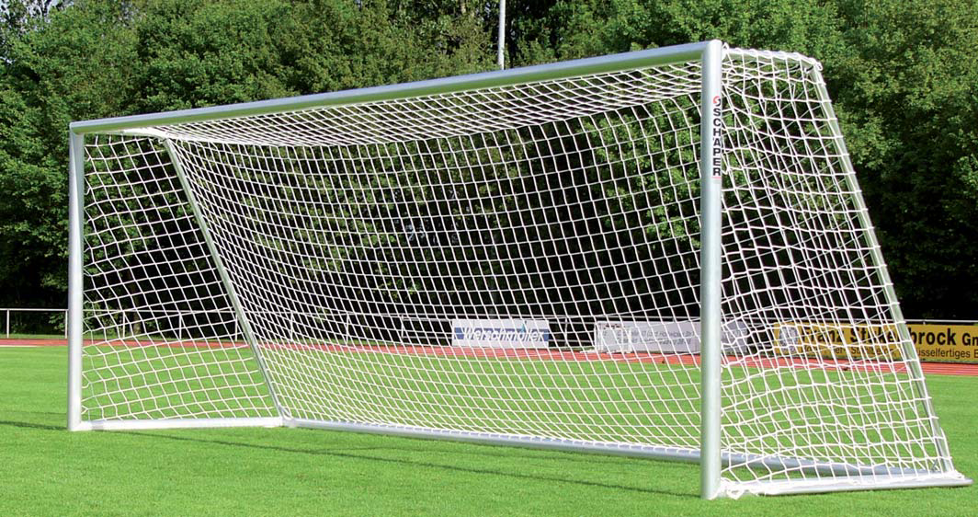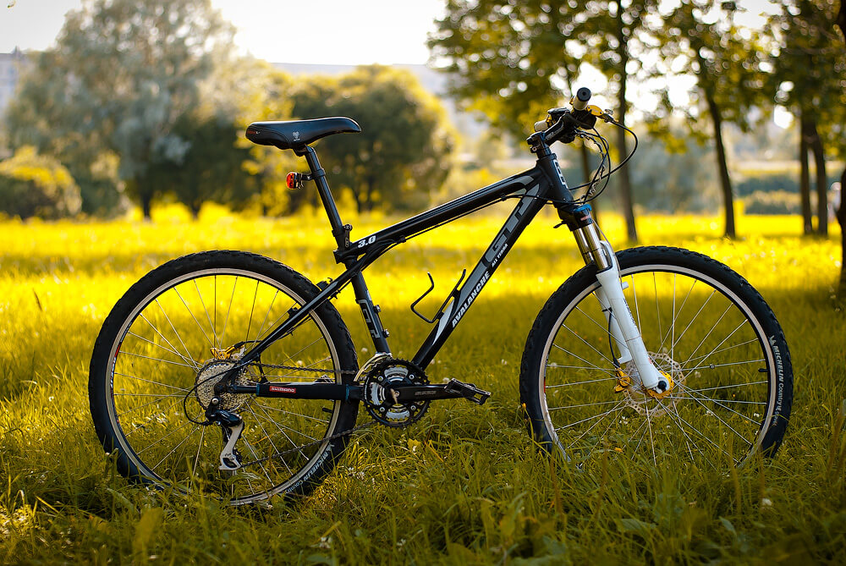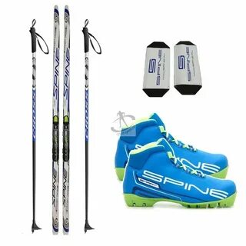
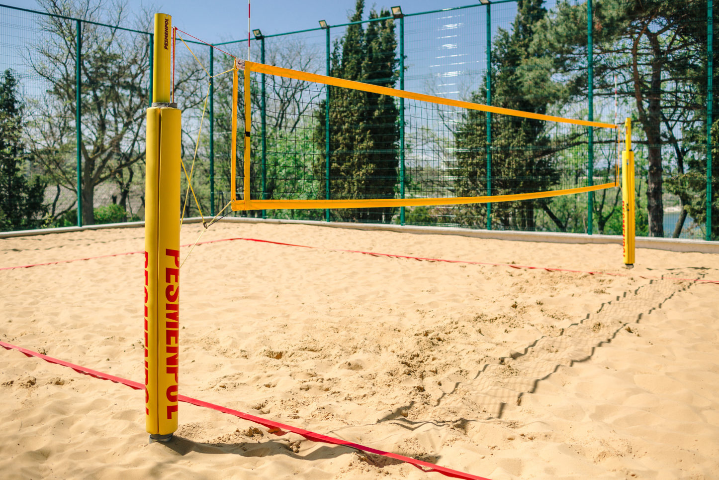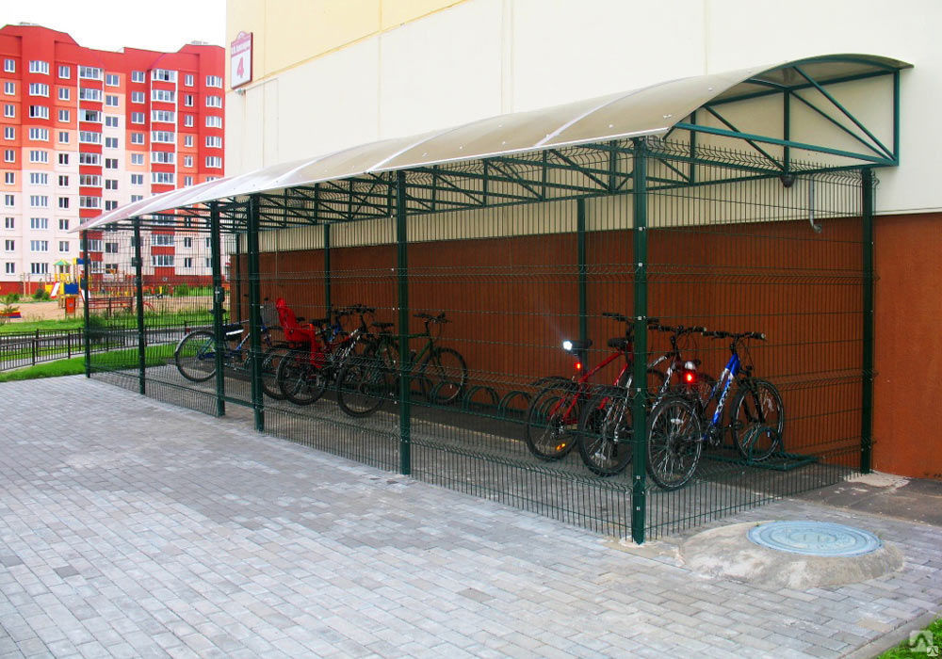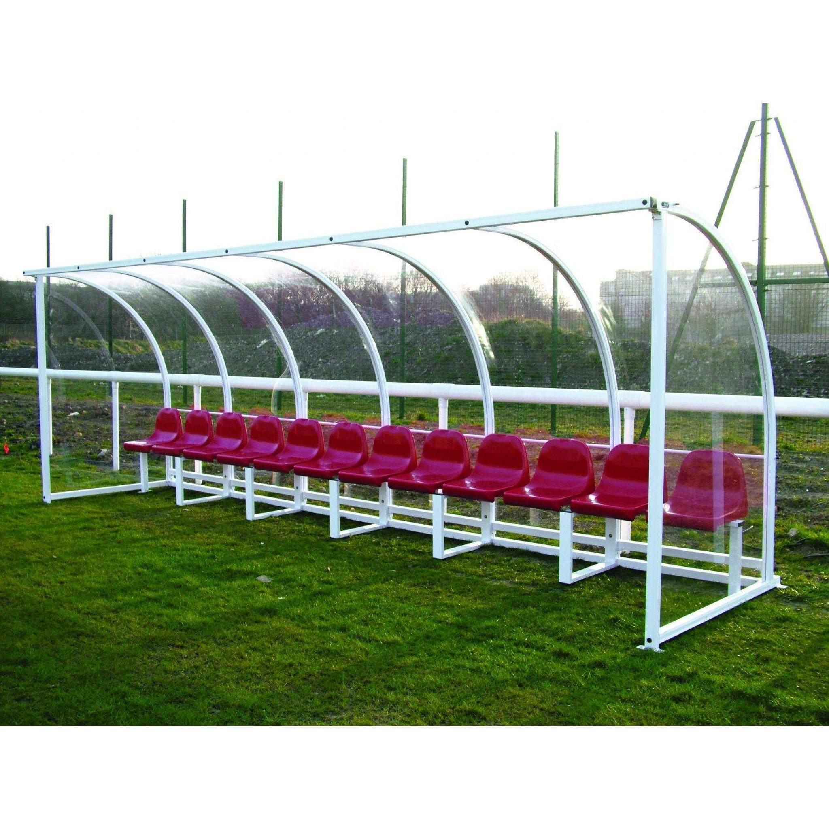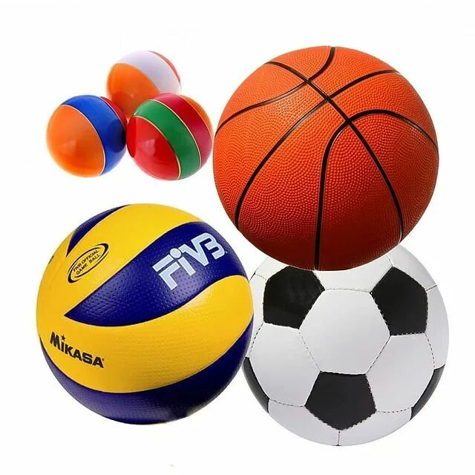
Project name: "Sports every day! Sports for everyone!"

Project implementation period: |  | 1 year from the start of the project
Location of the project: |  | Vitebsk region, Liozno, Maria Oktyabrskaya str., 75B, "City Stadium"
The applicant organization offering the project: |  | State Institution "Lioznensky District Physical culture and Sports Club"
Project objectives: |  | - Involvement of citizens of the town of Liozno and Liozno district in physical culture and sports;  - Development and improvement of the physical culture and sports infrastructure of the city stadium of Liozno for free and public, all-season physical education and sports, active and healthy leisure and recreation of citizens.
Project objectives: |  | Create the necessary infrastructure in the Lioznensky district for free and public, all-season exercise, sports, active leisure and recreation.  Improving the quality of life of people with disabilities and their family members, children and adolescents, pensioners through physical education and sports, organization of additional leisure.  Contribute to the formation of a sustained interest in regular physical education and sports.  Promote active types of physical culture and sports activities and a healthy lifestyle.
Brief description of the project:
"Sports every day! Sports for everyone!".
The activities of the state institution "Lioznensky District Sports Club" are aimed at popularizing and introducing people to a healthy lifestyle, taking measures to ensure that physical education and sports are available to all categories of citizens.
Street simulators have been installed at the city stadium of Liozno, which, according to the survey, are very popular among the population of the urban settlement, among the respondents are children and teenagers, youth, adults and the elderly, as well as people with disabilities. However, there are not enough places for changing clothes and storing things to improve the quality of training. In view of this, the presence of benches with a canopy for changing clothes is simply necessary so that everyone can calmly play sports and not think about where to find a place to change clothes and leave their belongings.
Football groups are training at the city stadium, in which about 140 children and teenagers are engaged, not counting young people and adults who regularly come to the stadium to play football. There are additional portable gates on the territory of the stadium, but they do not comply with safety standards, as they are very heavy, and the independent installation of gates on the field is prohibited by the management of the State Institution "Lioznensky District Sports Club", in order to prevent injuries. In this regard, it is necessary to purchase football gates that meet safety requirements.
In summer, the main means of transportation for all sports enthusiasts is a bicycle. At the same time, for many parents with children, this is the only way to get around, but, unfortunately, there are no parking lots for this type of transport on the territory of the stadium, and everyone leaves bicycles anywhere, which prevents movement around the stadium and physical education and sports, and can also cause injuries. In order to prevent such situations, it is necessary to install parking for bicycles at the entrance to the stadium.
Recently, the game of volleyball has been gaining popularity among residents of the town of Liozno. Fans of this sport gather at various adapted venues, thus the question arose about the possibility of creating a beach volleyball court. The placement of this site is planned near the roadway, so it is necessary to install additional fencing in order to avoid the ball hitting the roadway.
Unfortunately, there are no ski kits for those who want to master winter sports. There are a huge number of people who want to ski (according to the survey of respondents, many would like to try out a new sport, such as cross-country skiing, but do not have the opportunity).
Target group: | People with disabilities; sports enthusiasts; school students of the town of Liozno; pensioners; residents of the town of Liozno.
Total funding (in US dollars): 7170
Source of funding: | Amount of financing (in US dollars)
Donor funds: | US Dollars: 5784
Co-financing: | US Dollars: 1386
Contact person: | Deputy director of the state institution "Lioznensky District Sports Club" – Marchuk Olga Anatolyevna, 8(02138)53760, OLYA-OLYA.1982@MAIL.RU

